24.66: a) This situation is analagous to having two capacitors  in series, each with separation 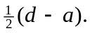 Therefore 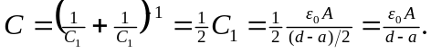
b) 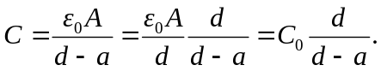
c) As

